A Day in the Life…
Japanese Internment Camps

A 50-minute Lesson Plan on the Japanese Internment Camps
For a Sixth Grade United States History Class
(24 Students in the Class)

Drew Clary
dclary1@gmail.com

Most Pure Heart of Mary School Alliance for Catholic Education
Mobile, Alabama Notre Dame, Indiana

Objective:
Students will be able to…
- …contrast different people’s perceptions and opinions of the internment camps based on their experiences with them.

Standards (Alabama State Standards):

6th Grade Social Studies

Standard 8: List key figures, significant events, and reasons for the involvement of the United States in World War II.
- Describing social costs associated with World War II

Standard 9: Identify changes in the American home front during World War II.
- Describing the changing role of African Americans and Japanese Americans in the society of the United States during World War II

Importance and Rationale:
This lesson forces students to approach the same issue from different perspectives. This is an essential skill in social studies, and one that is just as underdeveloped as it is unnatural for middle school students. By approaching the very same primary sources from different their assigned perspectives and then comparing their reactions with their classmates’, this skill will be not only developed but better appreciated as an important aptitude to develop.
Additionally, the development of civil rights for different parts of the population is a very important strand of American history in my class. It would be important in any class, but in a 100% African American school, it is especially so. This lesson aims to show that other demographic groups have also striven to achieve social and legal equity in their own ways.

Enduring Understanding:
The United States is a country that was settled and then formed out of the feeling of persecution. Many different populations have experienced different forms of persecution and suspension of civil rights throughout the course of American history. This may well be a common experience in each citizen’s personal history that is important to understand and empathize with.

Essential Questions:
What were the supposed benefits of Japanese internment?
How was internment experienced by various types of people in America?

Background:
Teachers should know about the popular anti-Asian sentiments that grew more acute following the attack on Pearl Harbor. A knowledge of FDR’s Executive Order, what life in internment camps was like, and subsequent Supreme Court decisions would be helpful as well.

Key Vocabulary:
Internment, prejudice, civil rights, Pearl Harbor

Location:
Standard Classroom

Materials:
- Deck of playing cards (or a way to group students)
- Primary sources for stations
- LCD projector and computer
- Packets of introductory information for each segment of population
- Guided notes sheet for completion of activities

Preparation:
- Around the classroom, tape stations with the primary sources to the wall where they will be easily visible and accessible to students as they move across the room. Next to each station, tape the clubs card that corresponds with the station where each group will begin
- Set up projector and computer to show clips from Internet
- Set up copies of introductory packets so students can pick them up during lesson

Resources for Japanese Internment Camps:
- http://americanhistory.si.edu/perfectunion/experience/index.html (Smithsonian Exhibit)
- http://www.sfmuseum.org/war/evactxt.html (The Virtual Museum of the City of San Francisco)
- http://www.archives.gov/research/alic/reference/military/japanese-internment.html (National Archives)

Sequence of Lesson Plan:

5 Minutes: Warm-Up (“Hook” or “Anticipatory Set”):
- Play a clip of a video that shows a salute to American freedom and democracy. (I would recommend History’s “Obama Makes History” clip from their America: The Story of Us series, found at http://www.history.com/shows/america-the-story-of-us/videos/obama-makes-history#obama-makes-history)
- Students view and answer reflection questions that ask them to reflect on whether these rights and freedoms have always been the case for all Americans
- As clip is playing, deal cards (so that there are 8 groups of 3 – each group should have the same number (Ace through 8) and one person with hearts, one with spades, and one with diamonds)

3 Minutes: Chalk-Talk
- Give each student a Post-It note and ask them to write the name of one group of people who were once denied equal rights in the US
- As they finish writing, they may come up to the board 4 at a time to stick their ideas to the chalkboard
- After posting their response (on their way back to their seat), have students pick up the handout and guided notes sheet on the front table

10 Minutes: Read Introductory Packets (Pages 5-6)
- Students read summary internment camps and answer brief questions
- When students have finished reading, they should move to their starting places.

16 Minutes: Stations (Guided Notes on Page 7, Station Printouts on Pages 9-17)
- Students start at stations (4 stations repeated so that there are 8 stations total)
- Students fill out appropriate box according to group identity and individual role
  - Aces and Fives = Interned Japanese Shop Owner
  - Twos and Sixes = Interned Japanese Child
  - Threes and Sevens = Internment Camp Guard
  - Fours and Eights = White American from Alabama
  - Diamonds = Fact Finder
  - Hearts = Angel Conscience
  - Spades = Devil Conscience
- After four minutes at a station, ding bell to rotate
  - At each station, all partners should share their findings so that within each group at each station, a complete row of the organizer is filled in
- After going through four stations, students should have seen all content and filled page one of guided notes sheet
- On bell after final station, students return to desks in groups by suit (not number)
  - Spades in groups 1, 2, 3, 4 get together
  - Spades in groups 5, 6, 7, 8 get together
  - Diamonds in groups 1-4 get together
  - Diamonds in groups 5-8 get together
  - Hearts in groups 1-4 get together
  - Hearts in groups 5-8 get together

8 Minutes: In New Groups (Page 8)
- One person in each group is from each perspective. In first two minutes, one person shares his/her findings
- Bell dings and next person gets two minutes to share his/her findings
- After working around the group, all students should have both pages of Guided Notes sheet complete

8 Minutes: Assessment (Assignment on Page 18, Rubric on Page 19)
- Students will outline a letter to President Roosevelt explaining how at least two groups of people felt in experiencing the internment camps
- Students may turn in organizer to see what was gleaned from activity
- Students may create a mural or political poster that shows what life in the internment camps was like

Extension
- Students may be asked to complete a Venn Diagram that contrasts German concentration camps for Jews with American internment camps for Japanese citizens
- Students may be analyze the Supreme Court’s logic in Korematsu v. United States

Lesson Resources:

Background Information Packet (textbook may be used if it provides sufficient background knowledge).

Executive Order 9066: Resulting in the Relocation of Japanese (1942)
Between 1861 and 1940, approximately 275,000 Japanese immigrated to Hawaii and the mainland United States. Japanese Americans settled in ethnic neighborhoods and established their own schools, houses of worship, and economic and cultural institutions. Ethnic concentration was increased because many real estate agents would not sell properties to Japanese Americans outside of existing Japanese neighborhoods. In 1913, the California Assembly passed an act that restricted land ownership. In 1922 the U.S. Supreme Court allowed the government to deny U.S. citizenship to Japanese immigrants.
Jealousy over economic success, distrust over cultural separateness, and long-standing anti-Asian racism turned into disaster when the Empire of Japan attacked Pearl Harbor on December 7, 1941. Congress and the President were convinced to remove persons of Japanese descent from the west coast, both foreign-born and American citizens. The U.S. Army carried out the task of relocating Japanese immigrants and citizens. The West Coast was divided into military zones, and on February 19, 1942, President Franklin D. Roosevelt issued Executive Order 9066 authorizing exclusion. Congress then implemented the order on March 21, 1942, by passing Public Law 503.
After encouraging voluntary evacuation of the areas, the Western Defense Command began forced removal and detention of West Coast residents of Japanese ancestry. In the next 6 months, approximately 122,000 men, women, and children were moved to assembly centers. They were then evacuated to and confined in isolated, fenced, and guarded relocation centers, known as internment camps. The 10 relocation sites were in remote areas in 6 western states and Arkansas: Heart Mountain in Wyoming, Tule Lake and Manzanar in California, Topaz in Utah, Poston and Gila River in Arizona, Granada in Colorado, Minidoka in Idaho, and Jerome and Rowher in Arkansas.
Nearly 70,000 of the evacuees were American citizens. The government made no charges against them, nor could they appeal their detention. All lost their personal liberties; most lost homes and property as well. Although several Japanese Americans challenged the government’s actions in court cases, the Supreme Court upheld their legality. Japanese citizens were encouraged to serve in the armed forces, and some were also drafted into the military. More than 30,000 Japanese Americans served with distinction during World War II in segregated units.
For many years after the war, various individuals and groups sought compensation for the internees. The speed of the evacuation forced many homeowners and businessmen to sell out quickly; total property loss is estimated at $1.3 billion, and net income loss at $2.7 billion (calculated in 1983 dollars based on the Commission investigation below).

- Did Japanese immigrants mix in with other ethnic groups when they came to the United States? What was one reason that they did or did not?
______________________________________________________________________________

______________________________________________________________________________

______________________________________________________________________________

- What branches of government played a role in relocating and detaining Japanese citizens and immigrants?
______________________________________________________________________________

______________________________________________________________________________

- How many people of Japanese descent were detained? How many of them were American citizens?

______________________________________________________________________________

______________________________________________________________________________

- Underline the names and locations of the internment camps.

- What was the value of Japanese property lost due to removal to internment camps?

______________________________________________________________________________

______________________________________________________________________________

______________________________________________________________________________

Guided Notes Sheet, Part I(to use as groups travel around to stations)

Roles within Group:
- Diamond: Fact Finder (find facts from resources relevant to group)
- Heart: “Angel Conscience” (what would someone with a “good conscience” think in your position?)
- Spade: “Devil Conscience” (what would someone with a “bad conscience” think in your position?)

Group Roles:
- Aces and Fives: Interned Japanese Shopowner
- Twos and Sixes: Interned Japanese Child
- Threes and Sevens: Internment Camp Guard
- Fours and Eights: White American from Alabama

 | Fact-Finder (Diamond) | Angel Reaction (Heart) | Devil Reaction (Spade)
Station
1 or 5

Station
2 or 6

Station
3 or 7

Station
4 or 8

Guided Notes, Part 2 (copied on back of previous page, for use in second groupings)

My Perspective: _________________________________

Other Perspectives: _______________________________________ (#1 below)

_______________________________________ (#2 below)

_______________________________________ (#3 below)

 | How this perspective is similar to mine | How this perspective differs from mine
Other Perspective #1

Other Perspective #2

Other Perspective #3

Station Resources

Stations #1 and #5
Photographs of Removal and Internment Camps

“First Day at Stockton”
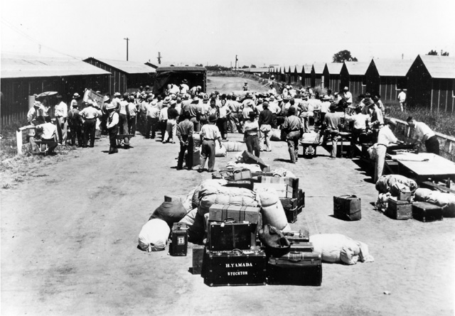
Temporary assembly centers were the first stop for most internees. Internees remained here until the War Relocation Authority camps were ready.

Fact-Finder: What facts can you figure out about these camps?

Angel Conscience: What would you be telling the person whose perspective you are taking based on these photos?

Devil Conscience: What would you be telling the person whose perspective you are taking based on these photos?

“Panorama of Amache, Colorado”
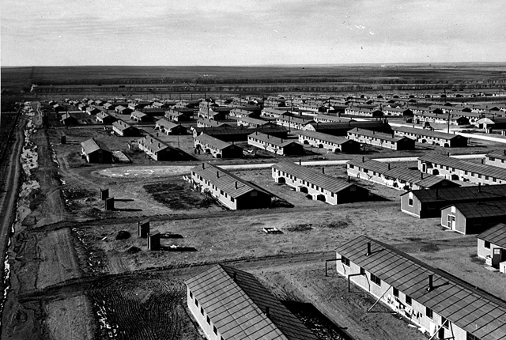

“From 1942 to 1946, home for most Japanese Americans was one of 10 WRA camps, all patterned on military facilities. Hastily built, with tarpaper walls and no amenities, the barracks were hot in summer and cold in winter. Most did not meet minimal standards for military housing. A visiting judge noted that prisoners in federal penitentiaries were better housed.”

Fact-Finder: What would your type of person think upon viewing these resources?

Angel Conscience: What would you be telling the person whose perspective you are taking based on these photos?

Devil Conscience: What would you be telling the person whose perspective you are taking based on these photos?

Stations #2 and #6
Life at the Internment Camps

“During the winter, our wet hair became frozen, and our fingers would stick to the metal door knob because we had to walk outdoors back to our barracks [after a shower].”
- Shigeru Yabu, Heart Mountain Wyoming Foundation
--------
“High School Football Game”
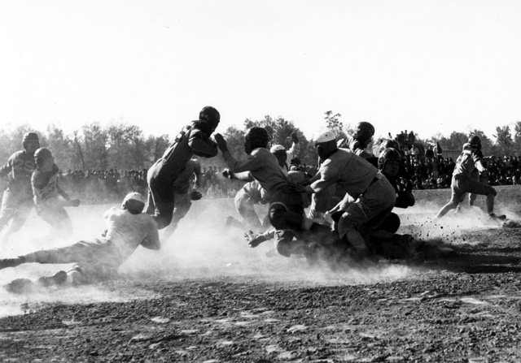

"Sports were real important. We'd get up and play basketball, baseball. I was on the basketball team and I helped coach football. I remember we had to buy our own baseballs and basketballs from Sears, and our own uniforms and set up our own league. We had championship playoffs. It's funny, but I think sports were one of the key factors that kept people from going astray, or feeling dissatisfied in camp. If it weren't for those athletic leagues, I think there would have been much more dissension."
Jack Matsuoka, in Beyond Words: Images from America's Concentration Camps

“Boy Scouts Carrying Flag”
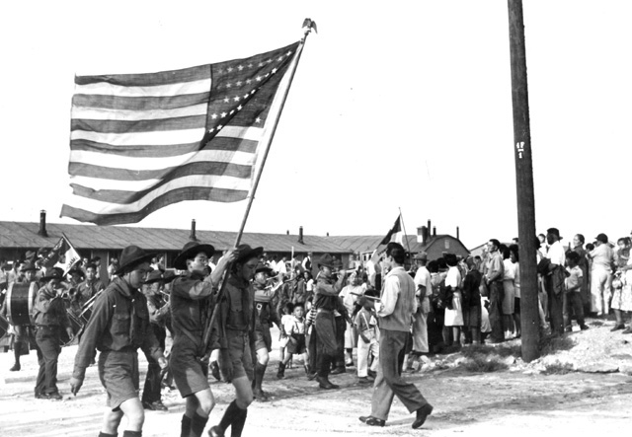"In most ways it was a totally equipped American small town, complete with schools, churches, Boy Scouts, beauty parlors, neighborhood gossip, fire and police departments, glee clubs, softball leagues, Abbott and Costello movies, tennis courts, and traveling shows."
-Jeanne Wakatsuki Houston and James D. Houston, Farewell to Manzanar

Fact-Finder: What would your type of person think upon viewing these resources?

Angel Conscience: What would you be telling the person whose perspective you are taking based on these primary sources?

Devil Conscience: What would you be telling the person whose perspective you are taking based on these primary sources?

Stations #3 and #7
Outside Opinions

Their Best Way to Show Loyalty
An Editorial

Japanese leaders in California who are counseling their people, both aliens and native-born, to co-operate with the Army in carrying out the evacuation plans are, in effect, offering the best possible way for all Japanese to demonstrate their loyalty to the United States.
Many aliens and practically all the native-born have been protesting their allegiance to this Government. Although their removal to inland districts outside the military zones may inconvenience them somewhat, even work serious hardships upon some, they must certainly recognize the necessity of clearing the coastal combat areas of all possible fifth columnists and saboteurs. Inasmuch as the presence of enemy agents cannot be detected readily when these areas are thronged by Japanese the only course left is to remove all persons of that race for the duration of the war.
That is a clear-cut policy easily understood. Its execution should be supported by all citizens of whatever racial background, but especially it presents an opportunity to the people of an enemy race to prove their spirit of co-operation and keep their relations with the rest of the population of this country on the firm ground of friendship.
…
Real danger would exist for all Japanese if they remained in the combat area. The least act of sabotage might provoke angry reprisals that easily could balloon into bloody race riots.
We must avoid any chance of that sort of thing. The most sensible, the most humane way to insure against it is to move the Japanese out of harm’s way and make it as easy as possible for them to go and to remain away until the war is over.
The San Francisco News
March 6, 1942

“All Packed Up and Ready to Go”
Political Cartoon from the San Francisco News, March 6, 1942
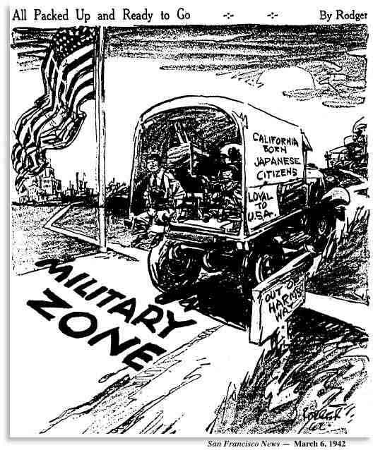
Fact-Finder: What would your type of person think upon viewing these resources?

Angel Conscience: What would you be telling the person whose perspective you are taking based on these sources?

Devil Conscience: What would you be telling the person whose perspective you are taking based on these sources?
Stations #4 and #8
Returning from the Camps

Stone Gatehouse in Field, Manzanar (April, 1985)
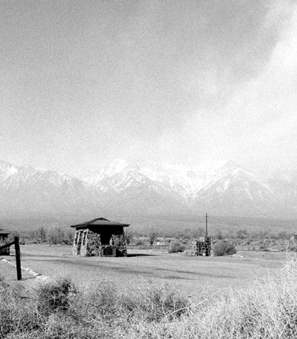
"The barracks are gone, torn down right after the war. The guard towers are gone, and the mess halls and shower rooms, the hospital, the tea gardens, and the white buildings outside the compound. Even the dust is gone. Spreading brush holds it to the ground...
What you see from the road are the two gatehouses, each a small empty pillbox of a building faced with flagstones and topped, like tiny pagodas, with shingled curving roofs." [emphasis added]
Jeanne Wakatsuki Houston and James D. Houston, Farewell to Manzanar

“Closing: We Won’t Take it to Owens Valley for U”
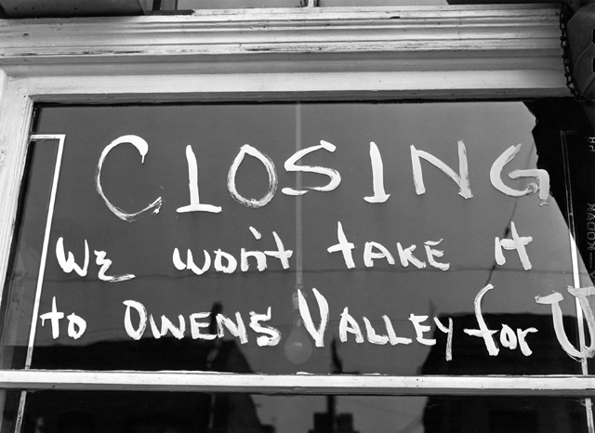
"Los Angeles, California. Last call to pick up suits and gowns before shades were pulled down in "Little Tokyo" prior to evacuation of residents of Japanese ancestry. Many were assigned to Manzanar War Relocation Authority center, in Owens Valley, California."

“Homes of Japanese Americans”
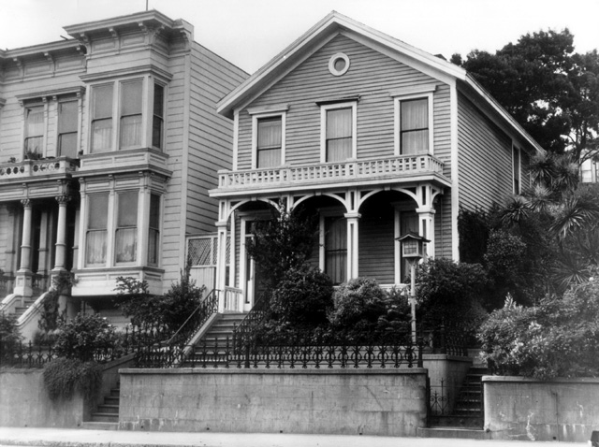
"San Francisco, California. Homes of Japanese ancestry on Bush Street. Occupants were evacuated and will be housed in War Relocation Authority centers for the duration."

Headlines in The San Francisco Examiner on January 21, 1945
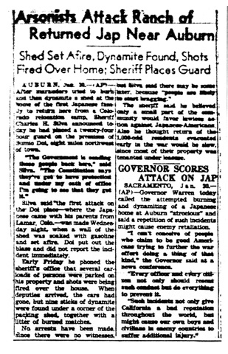
Fact-Finder: What would your type of person think upon viewing these resources?

Angel Conscience: What would you be telling the person whose perspective you are taking based on these sources?

Devil Conscience: What would you be telling the person whose perspective you are taking based on these sources?

Outline a Letter to President Roosevelt
Essay Question (Write it here): Write a letter to President Roosevelt that outlines how at least two groups of people we discussed today felt about the Japanese Internment Camps.

Introduction (Only do AFTER you have completed BODY)
Topic Area 1 Topic Area 2 Topic Area 3

Body (START HERE)
Type of Person Evidence/ Argument (connect to essay question above)

Conclusion (only do AFTER completed BODY AND INTRODUCTION –Do LAST)

Research Report : Letter to FDR

Teacher Name: Mr. Clary
Student Name: ________________________________________

CATEGORY | 4 | 3 | 2 | 1
Organization | Graphic organizer or outline has been completed and shows clear, logical relationships between all topics and subtopics. | Graphic organizer or outline has been completed and shows clear, logical relationships between most topics and subtopics. | Graphic organizer or outline has been started and includes some topics and subtopics. | Graphic organizer or outline has not been attempted.
Use of Resources | Information clearly relates to the main topic. It includes three supporting details/examples from today's stations for each type of person chosen. | Information clearly relates to the main topic. It includes two supporting details/examples from today's stations for each type of person chosen. | Information clearly relates to the main topic. It includes one supporting details/examples from today's stations for each type of person chosen. | Information has little or nothing to do with the main topic.
Guided Notes Sheet | All boxes in graphic organizer are filled with information from station work. | More than half the boxes in graphic organizer are filled with information from station work. | Less than half the boxes in graphic organizer are filled with information from station work. | Information in boxes is scribbled, illegible, and/or not appropriate for the box it is placed into.

Total: ________/12

A: 11-12
B: 9-10
C: 7-8
F: <7

Notes Abbreviated from http://www.ourdocuments.gov/print_friendly.php?flash=true&page=&doc=74&title=Executive+Order+9066:++Resulting+in+the+Relocation+of+Japanese+(1942)
Resources in this station from the Smithsonian’s “A More Perfect Union” exhibit (http://americanhistory.si.edu/perfectunion/experience/index.html)
http://americanhistory.si.edu/perfectunion/collection/image.asp?ID=821
http://americanhistory.si.edu/perfectunion/collection/image.asp?ID=274
Resources in this station from the Smithsonian’s “A More Perfect Union” exhibit (http://americanhistory.si.edu/perfectunion/experience/index.html)
Quote in subsection entitled “Home = Barracks” under “Internment” section
http://americanhistory.si.edu/perfectunion/collection/image.asp?ID=327
http://americanhistory.si.edu/perfectunion/collection/image.asp?ID=336
Resources in this station from The Virtual Museum of the City of San Francisco (http://www.sfmuseum.org/war/evactxt.html)
The San Francisco News, “Their Best Way to Show Loyalty.” Editorial: March 6th, 1942. (http://www.sfmuseum.org/hist8/editorial1.html)
The San Francisco News, “All Packed Up and Ready to Go.” Political Cartoon: March 6th, 1942. (http://www.sfmuseum.org/hist8/editorial4.html)
Resources in this station from the Smithsonian’s “A More Perfect Union” exhibit (http://americanhistory.si.edu/perfectunion/experience/index.html)
http://americanhistory.si.edu/perfectunion/collection/image.asp?ID=706
http://americanhistory.si.edu/perfectunion/collection/image.asp?ID=624
http://americanhistory.si.edu/perfectunion/collection/image.asp?ID=999
http://americanhistory.si.edu/perfectunion/collection/image.asp?ID=896

