Angel Island:
Twentieth Century
Immigration in the West

11th Grade United States History
One 60 Minute Lesson Plan

Jonathan Koop
University of Notre Dame
Alliance For Catholic Education
Duration: One 60-minute class period
Grade Level: 11th Grade
Number of Students: 30 students
Location: Classroom setting, 10 different stations set up around room (5 for Angel Island / 5 for Ellis Island
Key Vocabulary: Immigration, Detention, Prejudice, Perspective, Bias
Instructional Materials: See attached Appendix
Enduring Understanding: Immigration is an important issue that has consistently been the cause of divisive problems in the United States. In this lesson students will be introduced to the difficulties that people immigrating to the United States have faced both in the past and present. More importantly, however, students will learn how to examine experiences and events from multiple perspectives. This is an essential skill that all citizens must possess in order to understand why people react differently to various circumstances.
Essential Question: How have immigrants been treated when they arrive in the United States in both past and present? Why have Americans responded to immigration in this way?
Learning Objective: SWBAT: Compare treatment and acceptance of immigrants coming to the United States from Angel and Ellis Island during the early 20th Century.

Standards: Texas Standards: TEKS: 11.2(C ); 11.5 (A); 11.9(A,B); 11.10 (A,B);
NCSS Teacher Standards:
Thematic Standards: 1 (Culture and Cultural Diversity), 2 (Time, Continuity and Change), 3 (People, Places and Environment), 5 (Individuals, Groups and Institutions), 9 (Global Connections), 10 (Civic Ideals and Practices)
Disciplinary Standards: 1 (History), 2 (Geography), 5 (Psychology)
Background: The teacher should be familiar with the waves of immigration to the United States during the early 20th Century, and how/why immigrants from different parts of Europe were treated differently. Familiarity with the function/purpose of Angel and Ellis Island will also be helpful for conducting the class.
Suggested Procedure: See attached Lesson Plan
Evaluation: Students will read The New Colossus by Emma Lazarus and write a 2-3 sentence reaction from the perspective of a Chinese, European, and Hispanic immigrant.
Extensions: --Explore the website Angel Island: Immigrant Journeys of Chinese-Americans (http://www.angel-island.com/history.html)
--Explore the History Channel’s video segments about life on Ellis Island.
--Students can select a famous immigrant who came to the United States during the early 20th century and conduct a research project to discover what impact that person had on the United States.
--Students can conduct individual (but guided) research into the on-going immigration debate in the United States and then write a letter to an elected representative (President, Congressman, Governor, etc.) expressing their views. Then send these letters and see if the letter receives a response.
Resources: See attached Appendix.

Role Cards
Name: Beck H. Gee
Nationality: Chinese
Immigrations Station: Angel Island
Round 1: 1-Immigrant Coming to U.S.
Round 2: A

Role Cards
Name: Helen Wong
Nationality: Chinese
Immigrations Station: Angel Island
Round 1: 1-U.S. Citizen Opposed to Immigration
Round 2: B

Role Cards
Name: Lester Tom Lee
Nationality: Chinese
Immigrations Station: Angel Island
Round 1: 1—Unbiased Observer
Round 2: C

Role Cards
Name: Henry S.H. Gee
Nationality: Chinese
Immigrations Station: Angel Island
Round 1: 2—Immigrant Coming to U.S.
Round 2: D

Role Cards
Name: Lydia Lum
Nationality: Chinese
Immigrations Station: Angel Island
Round 1: 2-U.S. Citizen Opposed to Immigration
Round 2: E

Role Cards
Name: Lium Hu
Nationality: Chinese
Immigrations Station: Angel Island
Round 1: 2—Unbiased Observer
Round 2: F

Role Cards
Name: Fen Chen
Nationality: Chinese
Immigrations Station: Angel Island
Round 1: 3—Immigrant Coming to U.S.
Round 2: G

Role Cards
Name: Nin Xing
Nationality: Chinese
Immigrations Station: Angel Island
Round 1: 3-U.S. Citizen Opposed to Immigration
Round 2: H

Role Cards
Name: Jin Zhou
Nationality: Chinese
Immigrations Station: Angel Island
Round 1: 3—Unbiased Observer
Round 2: I

Role Cards
Name: Huang Xu
Nationality: Chinese
Immigrations Station: Angel Island
Round 1: 4—Immigrant Coming to U.S.
Round 2: J

Role Cards
Name: Shen Gao
Nationality: Chinese
Immigrations Station: Angel Island
Round 1: 4-U.S. Citizen Opposed to Immigration
Round 2: K

Role Cards
Name: Yi-Min He
Nationality: Chinese
Immigrations Station: Angel Island
Round 1: 4—Unbiased Observer
Round 2: L

Role Cards
Name: Jia Wang
Nationality: Chinese
Immigrations Station: Angel Island
Round 1: 5—Immigrant Coming to U.S.
Round 2: M

Role Cards
Name: Quon Li
Nationality: Chinese
Immigrations Station: Angel Island
Round 1: 5-U.S. Citizen Opposed to Immigration
Round 2: N

Role Cards
Name: Shen Yang
Nationality: Chinese
Immigrations Station: Angel Island
Round 1: 5—Unbiased Observer
Round 2: O

~~~~~~~~~~~~~~~~~~~~~~~~~~~~~~
Role Cards
Name: Louis Adamic
Nationality: Slovenia
Immigrations Station: Ellis Island
Round 1: 1-Immigrant Coming to U.S.
Round 2: A

Role Cards
Name: Charles Atlas
Nationality: Italian
Immigrations Station: Ellis Island
Round 1: 1-U.S. Citizen Opposed to Immigration
Round 2: B

Role Cards
Name: Claudette Colbert
Nationality: French
Immigrations Station: Ellis Island
Round 1: 1—Unbiased Observer
Round 2: C

Role Cards
Name: Ricardo Cortez
Nationality: Austrian
Immigrations Station: Ellis Island
Round 1: 2-Immigrant Coming to U.S.
Round 2: D

Role Cards
Name: Donald Crisp
Nationality: Scottish
Immigrations Station: Ellis Island
Round 1: 2-U.S. Citizen Opposed to Immigration
Round 2: E

Role Cards
Name: Frank Capra
Nationality: Italian
Immigrations Station: Ellis Island
Round 1: 2—Unbiased Observer
Round 2: F

Role Cards
Name: Edward Flanagan
Nationality: Irish
Immigrations Station: Ellis Island
Round 1: 3-Immigrant Coming to U.S.
Round 2: G

Role Cards
Name: Bill Graham
Nationality: German
Immigrations Station: Ellis Island
Round 1: 3-U.S. Citizen Opposed to Immigration
Round 2: H

Role Cards
Name: Francis Hodur
Nationality: Polish
Immigrations Station: Ellis Island
Round 1: 3—Unbiased Observer
Round 2: I

Role Cards
Name: Bob Hope
Nationality: English
Immigrations Station: Ellis Island
Round 1: 4-Immigrant Coming to U.S.
Round 2: J

Role Cards
Name: John Kluge
Nationality: German
Immigrations Station: Ellis Island
Round 1: 4-U.S. Citizen Opposed to Immigration
Round 2: K

Role Cards
Name: Igor Sikorsky
Nationality: Russian
Immigrations Station: Ellis Island
Round 1: 4—Unbiased Observer
Round 2: L

Role Cards
Name: Barron von Trapp
Nationality: Austrian
Immigrations Station: Ellis Island
Round 1: 5-Immigrant Coming to U.S.
Round 2: M

Role Cards
Name: George Voskovec
Nationality: Czechoslovakian
Immigrations Station: Ellis Island
Round 1: 5-U.S. Citizen Opposed to Immigration
Round 2: N

Role Cards
Name: Knute Rockne
Nationality: Norwegian
Immigrations Station: Ellis Island
Round 1: 5—Unbiased Observer
Round 2: O

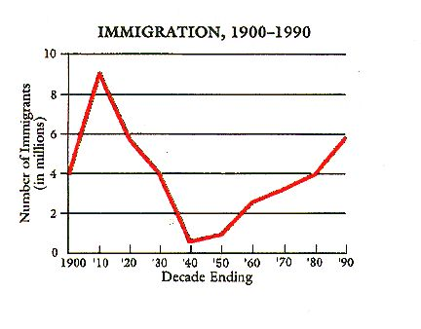

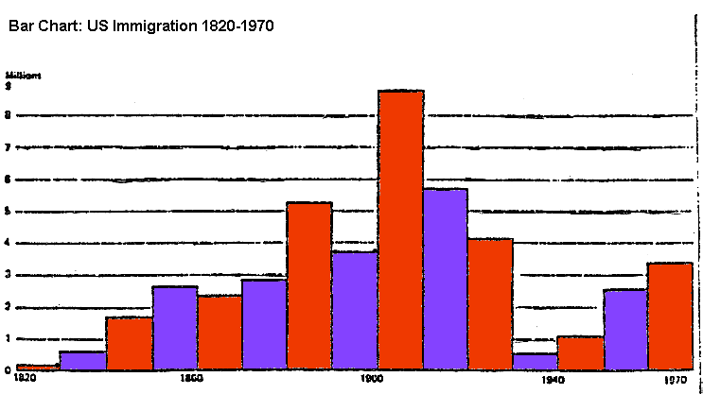
Angel Island Station #1:
Poems from Angel Island
Between 1910 and 1940, as many as 175,000 Chinese immigrants were detained and processed at Angel Island. Because of the Chinese Exclusion Act, Angel Island served more as a detention and deportation center than an immigration processing center. Life for the detainees was strange, stressful, demoralizing, and humiliating. After the Angel Island detention center closed down, thousands of poems were found etched into the walls of the building, providing us insight into the experiences many of these immigrants had while there.
After you are finished reading this except, watch the following video clip to help you fill out your graphic organizer.
http://www.youtube.com/watch?v=f_EQY0ThOM&feature=player_embedded

Poem #1
There are tens of thousands of poems on these walls
They are all cries of suffering and sadness
The day I am rid of this prison and become successful
I must remember that this chapter once existed
I must be frugal in my daily needs
Needless extravagance usually leads to ruin
All my compatriots should remember China
Once you have made some small gains,
you should return home early.

Poem #2
America has power, but not justice.
In prison, we were victimized as if we were guilty.
Given no opportunity to explain, it was really brutal.
I bow my head in reflection but there is
nothing I can do.
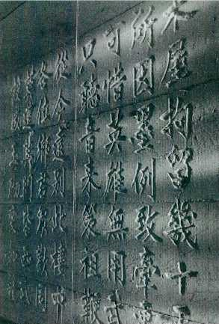http://rpp.english.ucsb.edu/wp-content/uploads/2006/08/poems1.jpg
http://www.cetel.org/angel_poetry.html
--Ancestors in the Americas

- Immigrant Attempting to Enter U.S.: How would an immigrant attempting to enter the United States in the early 20th century feel about these primary sources?

- U.S. Citizen Opposed to Immigration: How would a United States citizen who is opposed to immigration in the early 20th century feel about these primary sources?

- Unbiased Observer: How would an unbiased observer in the early 20th century feel about these primary sources?
Angel Island Station #2:
Medical Examinations on Angel Island
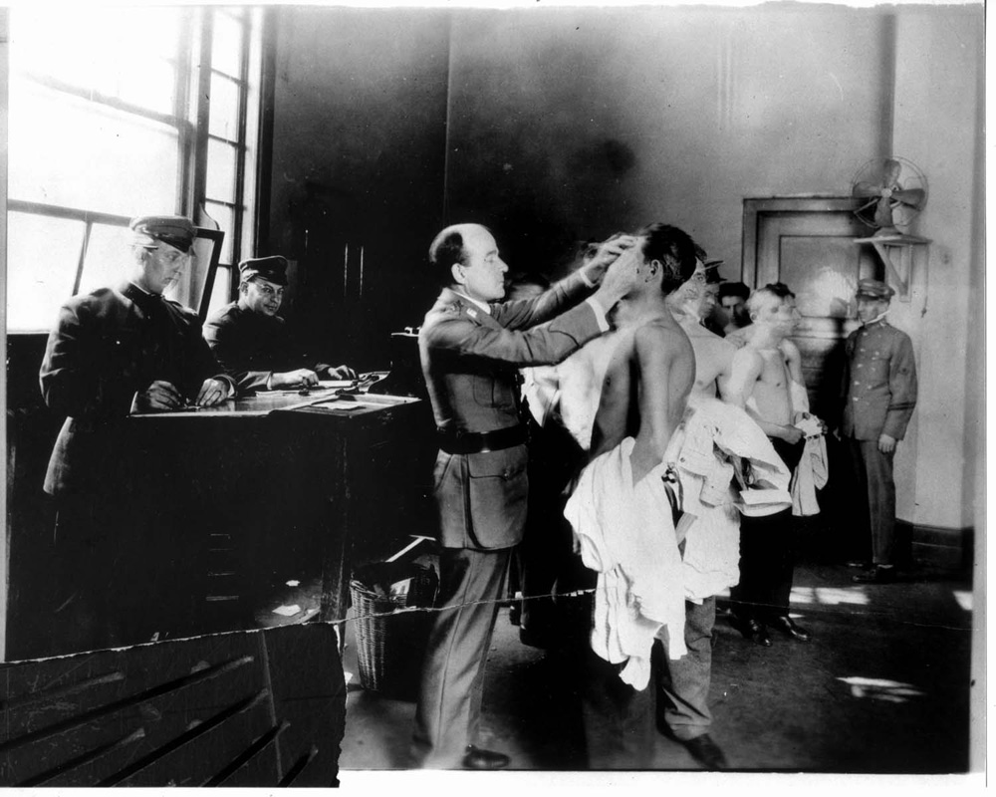
http://rpp.english.ucsb.edu/wp-content/uploads/2006/08/angel_island_1_lg.jpg --Race and Pedagogy Project
With increasing government regulations, it became impossible to effectively screen immigrants in the two-story shed at the Pacific Mail Steamship Company wharf in San Francisco. The Bureau of Immigration followed the example of New York City’s founding of an immigrant station on Ellis Island separated from the city itself. Established in 1910, the Angel Island detention center near San Francisco included barracks, a hospital, and various administrative buildings. Here, immigrants could be isolated; both to protect the population from communicable diseases and to provide time for examination of possible fraudulent entry claims.
Upon arrival in San Francisco, Europeans and first- and second-class travelers were usually processed on board and allowed to disembark directly to the city. All others were ferried to Angel Island where the men and women were separated before undergoing stringent medical tests, performed with little regard for the dignity of the immigrant, looking particularly for parasitic infections.
http://immigration-online.org/20-angel-island.html --Encyclopedia of Immigration: Angel Island

- Immigrant Attempting to Enter U.S.: How would an immigrant attempting to enter the United States in the early 20th century feel about these primary sources?

- U.S. Citizen Opposed to Immigration: How would a United States citizen who is opposed to immigration in the early 20th century feel about these primary sources?

- Unbiased Observer: How would an unbiased observer in the early 20th century feel about these primary sources?
Angel Island Station #3:
Life in Detention on Angel Island
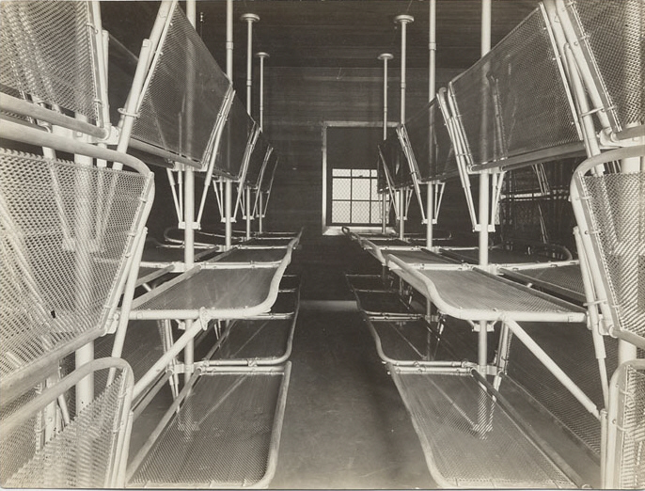
http://sunsite.berkeley.edu/cgi-bin/flipomatic/cic/images@ViewImage?img=brk00001197_16a
--Library of Congress: Chinese in California Collection

"Passing back through the dining-room, we climb the long, broad stairway that leads up to the two-story Chinese Detention Building for the men. Sometimes there are two or three hundred men and boys up here. Some are mere boys of twelve or so, the sons of San Francisco Chinese merchants, or the alleged 'sons,' whose real status it is the perplexing task of the United States Government to determine. When we were in the main room of the Administration Building, we noticed that a railed-off section held a number of Chinese. They were witnesses, come to testify in some of the Chinese cases that are decided here."
http://www.loc.gov/teachers/classroommaterials/connections/chinese-cal/history6.html --LOC

- Immigrant Attempting to Enter U.S.: How would an immigrant attempting to enter the United States in the early 20th century feel about these primary sources?

- U.S. Citizen Opposed to Immigration: How would a United States citizen who is opposed to immigration in the early 20th century feel about these primary sources?

- Unbiased Observer: How would an unbiased observer in the early 20th century feel about these primary sources?

Angel Island Station #4:
Prejudice Against the Chinese
Excerpt from For the re-enactment of the Chinese Exclusion Law
“…We respectfully represent that American labor should not be exposed to the destructive competition of aliens who do not, will not, and cannot take up the burden of American citizenship, whose presence is an economic blight and a patriotic danger…The Chinese are skilled and are capable of almost any skilled employment. They have invaded the cigar, shoe, broom, chemical, clothing, fruit canning, match making, wollen manufacturing industries, and have displaces more than 4,000 white men in these several employments in the city of San Francisco. As common laborers they have throughout California displaced tens of thousands of men.
". . . during their long residence but few intermarriages have taken place, and the offspring has been invariably degenerate. It is well established that the issue of the Caucasian and the Mongolian do not possess the virtues of either, but develop the vices of both. So physical assimilation is out of the question. . . . The purpose, no doubt, for enacting the exclusion laws for periods of ten years is due to the intention of Congress of observing the progress of those people under American institutions, and now it has been clearly demonstrated that they cannot, for the deep and ineradicable reasons of race and mental organization, assimilate with our own people, and be molded as are other races into strong and composite American stock.
“…The free immigration of Chinese would be for all purposes an invasion by Asiatic barbarians against whom civilization in Europe, fortunately for us, has been frequently defended. It is our inheritance to keep it pure and uncontaminated, as it is our purpose and destiny to broaden and enlarge it. We are trustees for mankind. "
http://sunsite.berkeley.edu/cgi-bin/flipomatic/cic/brk6586

- Immigrant Attempting to Enter U.S.: How would an immigrant attempting to enter the United States in the early 20th century feel about these primary sources?

- U.S. Citizen Opposed to Immigration: How would a United States citizen who is opposed to immigration in the early 20th century feel about these primary sources?

- Unbiased Observer: How would an unbiased observer in the early 20th century feel about these primary sources?

Angel Island Station #4:
Prejudice Against the Chinese (Continued)

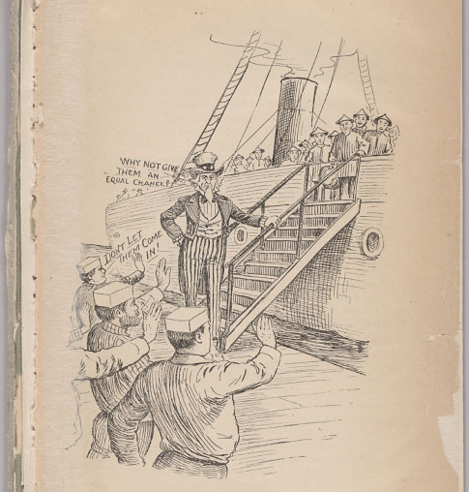
http://sunsite.berkeley.edu/cgi-bin/flipomatic/cic/brk4979

Angel Island Station #5:
Chinese Immigration Statistics

Total Immigration to the United States
During the 1880s | 5.2 million
During the 1890s | 3.7 million
During the 1900s | 8.8 million
During the 1910s | 5.7 million
During the 1920s | 4.1 million
During the 1930s | 0.5 million

Chinese-Born Population in the United States
In 1850 | 758
In 1860 | 35,565
In 1870 | 64,565
In 1880 | 104,468
In 1890 | 106,688
In 1900 | 81,534
In 1910 | 56,756
In 1920 | 43,560

Angel Island Statistics
Number of Chinese immigrants processed through the Immigration Station at Angel Island, California, between 1910 and 1940: | Approximately 175,000
Percentage of Immigrants Detained at Angel Island | 60%
Average length of detention at Angel Island for would-be Chinese immigrants: | 2 to 3 weeks
Longest length of detention at Angel Island for would-be Chinese immigrants: | More than 2 years
Total Percentage of Immigrants denied entry to the U.S. at Angel Island | 30%
Historical Statistics of the United States: Millennial Edition, http://hsus.cambridge.org/

- Immigrant Attempting to Enter U.S.: How would an immigrant attempting to enter the United States in the early 20th century feel about these primary sources?

- U.S. Citizen Opposed to Immigration: How would a United States citizen who is opposed to immigration in the early 20th century feel about these primary sources?

- Unbiased Observer: How would an unbiased observer in the early 20th century feel about these primary sources?
Ellis Island Station #1
Jubilation in Arriving at Ellis Island

The following is a reflection of the happiness people felt as they arrived in the United States after a long, crowded boat ride across the Atlantic Ocean from Europe. The trip meant days and sometimes months aboard overcrowded ships often traveling through hazardous weather. Substandard food and poor sanitation conditions only compounded the misery for many who had become sick aboard these ships. Nevertheless, the promise of freedom and opportunity made even the most arduous trips worth it.

“As the landing hour approached, steerage passengers (those who rode in the bottom of the boat) dressed in their best clothes. Women dug out their finest dresses. Men put on their finest derbies (shoes) and here and there stood boys in white suits… And there, finally appearing out of the mist, she loomed—the sea green figure of Liberty, torch high, seemingly striding toward the new-comers as though she had sighted them in greeting at the same instant they had sighted her in gratitude…The first thing some people did was get down on their knees and pray to God to thank God.
Some of the crowd on the deck sang or danced, or threw their hats into the air. Seeing the Statue of Liberty was the greatest thing I’ve ever seen. What a wonderful sight! To know you’re in this country...just to think of it. It was the feeling of coming to a land of freedom, a land of love. When we arrived it was like a dream. I tell you the God’s truth, it felt like a dream.”
--Stephanie Okunewitch and Arnold Weiss, immigrants to Ellis Island in 1921
http://isite.lps.org/lkingery/web/documents/EllisIslandArticle.pdf

- Immigrant Attempting to Enter U.S.: How would an immigrant attempting to enter the United States in the early 20th century feel about these primary sources?

- U.S. Citizen Opposed to Immigration: How would a United States citizen who is opposed to immigration in the early 20th century feel about these primary sources?

- Unbiased Observer: How would an unbiased observer in the early 20th century feel about these primary sources?

Ellis Island Station #2:
Examinations on Ellis Island

Physical: The medical inspection began as soon as the immigrants ascended the stairs to the Registry Room. U.S. Public Health Service Doctors stationed at the top of the stairs watched carefully for shortness of breath or signs of heart trouble as the immigrants climbed up the steps hefting their baggage. The doctors sometimes had only six seconds to scan each immigrant during the line inspection. If a doctor found any indication of disease, he marked the shoulder or lapel of an immigrant's clothing with chalk. Marked immigrants were removed from the inspection line and led to special examination rooms. There a doctor would check them for the ailment indicated by the chalk mark and give them a quick overall physical. Many had to be sent to the hospital for observation and care. Patients who recovered were usually allowed to land. Others, whose ailments were incurable or disabling, were sent back to their ports of origin.

"My sister developed warts on the back of her hand so they put a chalk 'X' on the back of her coat. The Xs were put aside to see whether they had to be reexamined or deported. If they deported my sister we couldn't let her go. Where would she go if they deported her? Some kind man, I don't know who he was, told my sister to turn her coat around. She had a nice plush coat with a silk lining, and they turned her coat around."
-Victoria Saifatti Fernández, a Macedonian immigrant in 1916
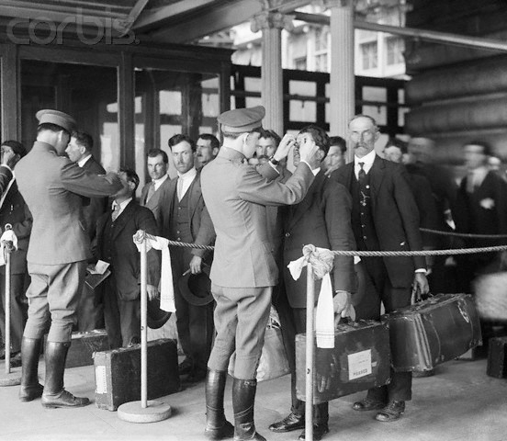
http://www.corbisimages.com/stock-photo/rights-managed/BE065410/inspection-of-immigrants-at-ellis-island
Ellis Island Station #2:
Examinations on Ellis Island (Continued)

Mental: In addition to using standard tests, Ellis Island doctors devised many of their own tests to help diagnose mental defects. Puzzle and mimicry tests were favored because they did not have to be explained to an immigrant through an interpreter; nor did an immigrant have to know how to read or write in order to solve them

The whole experience was very frightening...They brought me up to a room...They put a pegboard before me with little sticks of different shapes and little holes...I had to put them in place, the round ones and the square ones...and I did it perfectly. They said "Oh, we must have made a mistake. This little girl...naturally she doesn't know English, but she's very bright, intelligent." They took the cross (chalk mark) off me so we were cleared.

--Victoria Sarfatti Fernandez, a Macedonian Jewish immigrant in 1916, interviewed in 1985.

.
Can you draw a diamond?
http://www.powayusd.com/online/usonline/worddoc/ellisislandsite.htm

- Immigrant Attempting to Enter U.S.: How would an immigrant attempting to enter the United States in the early 20th century feel about these primary sources?

- U.S. Citizen Opposed to Immigration: How would a United States citizen who is opposed to immigration in the early 20th century feel about these primary sources?

- Unbiased Observer: How would an unbiased observer in the early 20th century feel about these primary sources?
Ellis Island Station #3
Detention on Ellis Island

During the peak years of immigration, detention (making people stay for extended periods of time) on Ellis Island ran as high as 20% for all immigrants inspected. A detainee's stay could last days or even weeks. Many were women and children who were waiting for a relative to come for them or for money to arrive. Others were waiting for a hearing in front of the board of special inquiry or for a final decision from Washington, D.C. Perhaps the most poignant of the detainees were the families waiting for a sick parent or child to be released from the Ellis Island hospital.
After you are finished reading this except, watch the following video clip to help you fill out your graphic organizer.
http://www.history.com/videos/immigrants-detained-at-ellis-island#immigrants-detained-at-ellis-island
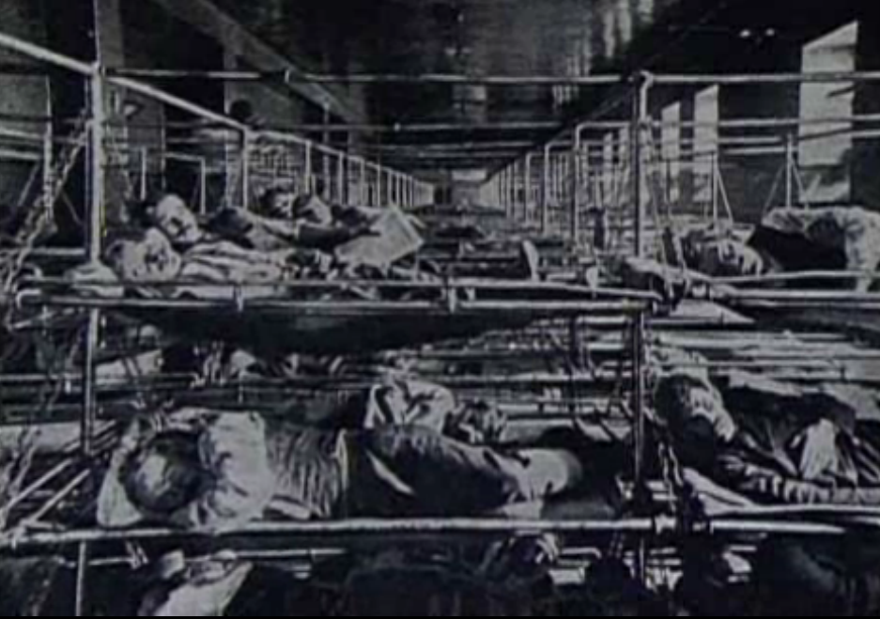
http://old.internationalchannel.com/education/ellis/
The time I spent on Ellis Island seemed like the longest waiting period for me because of the regimen. Naturally there had to be a regimen. it was the only way that they could handle that many people. I realize that now in retrospect. But at the time it was a nightmare...They weren't unkind, but you had no communication with the people who took care of you...And you had no communication with the other people that were there because everybody was so full of fright.
--Barbara Barondess, a Russian Jewish immigrant in 1921

- Immigrant Attempting to Enter U.S.: How would an immigrant attempting to enter the United States in the early 20th century feel about these primary sources?

- U.S. Citizen Opposed to Immigration: How would a United States citizen who is opposed to immigration in the early 20th century feel about these primary sources?

- Unbiased Observer: How would an unbiased observer in the early 20th century feel about these primary sources?
Ellis Island Station #4:
Prejudice Against European Immigrants

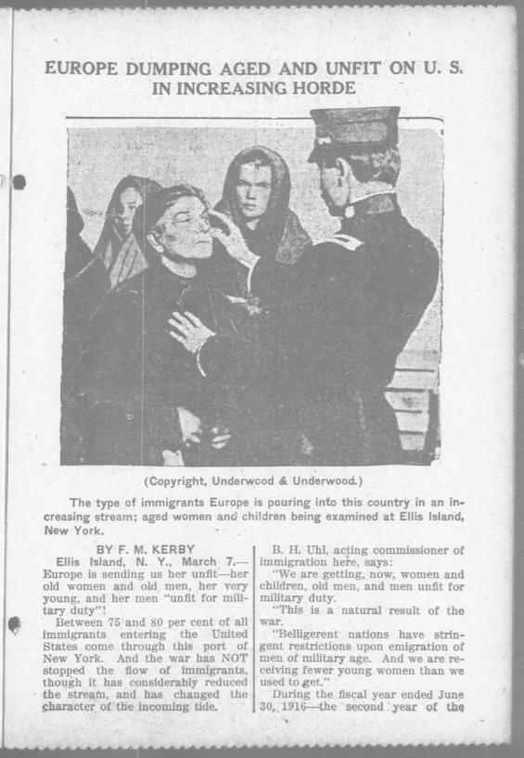
http://chroniclingamerica.loc.gov/lccn/sn83045487/1917-03-07/ed-1/seq-13/ --Library of Congress

- Immigrant Attempting to Enter U.S.: How would an immigrant attempting to enter the United States in the early 20th century feel about these primary sources?

- U.S. Citizen Opposed to Immigration: How would a United States citizen who is opposed to immigration in the early 20th century feel about these primary sources?

- Unbiased Observer: How would an unbiased observer in the early 20th century feel about these primary sources?
Ellis Island Station #5:
European Immigration Statistics

Total Immigration to the United States
During the 1880s | 5.2 million
During the 1890s | 3.7 million
During the 1900s | 8.8 million
During the 1910s | 5.7 million
During the 1920s | 4.1 million
During the 1930s | 0.5 million

European-Born Population in the United States
Percentage of America's foreign-born population in 1860 born in Great Britain, Ireland, or Germany: | More than 80%
Percentage of America's foreign-born population in 1910 born in Great Britain, Ireland, or Germany: | Less than 40%
Percentage of America's foreign-born population in 1860 born in Southern or Eastern Europe: | 1.2%
Percentage of America's foreign-born population in 1910 born in Southern or Eastern Europe: | 37.5%

Ellis Island Statistics
Number of European immigrants processed through the Immigration Station at Ellis Island, New York, between 1892 and 1954: | More than 16 million
Record number of immigrants processed through the Immigration Station at Ellis Island in a single day in 1907: | 11,747
Percentage of Immigrants Detained at Ellis Island | 20%
Total Percentage of Immigrants denied entry to the U.S. at Ellis Island | 2%
Historical Statistics of the United States: Millennial Edition. http://hsus.cambridge.org/

- Immigrant Attempting to Enter U.S.: How would an immigrant attempting to enter the United States in the early 20th century feel about these primary sources?

- U.S. Citizen Opposed to Immigration: How would a United States citizen who is opposed to immigration in the early 20th century feel about these primary sources?

- Unbiased Observer: How would an unbiased observer in the early 20th century feel about these primary sources?
Name: ________________________ Date:_____________ Period: ___________
Early 20th Century Immigration:
Angel Island vs. Ellis Island

Directions: Work with your assigned group members to visit each station from the correct immigration location. Be sure to fill in your columns from your assigned perspective, and then trade your answers with your group members to complete the chart.

Part 1: Analyzing an Immigration Station
At which Immigration Station are you arriving (Circle One): Angel Island Ellis Island

(Write Name of Station) | Immigrant Attempting to Enter U.S. | U.S. Citizen Opposed to Immigration | Unbiased  Observer
Station #1:

Station #2:

Station #3:

Station #4:

Station #5:

Part 2: Comparing Angel Island and Ellis Island

Directions: Join your newly assigned partner. Make sure that he/she had studied a different immigration station than you had. Now, using what you have learned about immigration at your particular location, compare and contrast the experiences of immigrants coming to American from the other side of the country.

 | How were the immigrants’ experiences at Angel / Ellis Island similar to mine? | How were the immigrants’ experiences at Angel / Ellis Island different from mine?
Reasons for Discrimination Against
Immigrants

Treatment of Immigrants at the Immigration Station

Expectations for Success and Achievement of that Success
(Look at Statistics)

A Connection to Today: The Hispanic Immigration Debate Reading

It's always been the same for the huddled masses (May 11, 2006) &
Arizona immigration law must pass the prejudice test (April 21, 2010)
~~~~~~~~
US: Whether Irish or Italians, Jews or Mexicans, immigrants to the US have perennially evoked fear and prejudice, writes Michael Powell in New York
They were portrayed as a disreputable lot, the immigrant hordes of this great city.
The Germans refused for decades to give up their native tongue and raucous beer gardens. The Irish of Hell's Kitchen brawled and clung to political sinecures. The Jews crowded into the Lower East Side, speaking Yiddish, fomenting socialism and resisting forced assimilation. And by their sheer numbers the immigrants depressed wages in the city.
The bitter arguments of the past echo loudly these days as Congress debates toughening the US's immigration laws and immigrants, mainly from Latin America and Asia, swell the streets of US cities in protest.
Most of the concerns voiced today - that too many immigrants seek economic advantage and fail to understand democracy, that they refuse to learn English, overcrowd homes and overwhelm public services - were heard a century ago. And there was a nub of truth to some complaints, not least that the vast influx of immigrants drove down working-class wages.
Yet historians and demographers are clear about the bottom line. In the long run, New York City - and the United States - owes much of its economic resilience to replenishing waves of immigrants…
Now another wave washes over. Fully 38 per cent of New York's eight million residents are foreign-born, nearly the same percentage as a century ago.
"It would be easy to say the short-run costs of immigration outweighed the benefits," says Joe Salvo, a director at New York's City Planning Department. "But the benefits are longer term. We wouldn't be the superpower we are if we hadn't let them in."
Advocates of stricter enforcement argue that those who came a century ago were different from today’s large population of Hispanic immigrants because they arrived legally. Films and novels depict customs agents at New York's Ellis Island - that keyhole through which 16 million immigrants passed from 1882 to 1922 - examining immigrants and their papers with a capricious eye toward shipping back laggards.
Peggy Noonan, a former speechwriter for President Reagan, wrote about her Irish forebears in a Wall Street Journal column: "They waited in line. They passed the tests. They had to get permission to come . . . They had to get through Ellis Island . . . get questioned and eyeballed by a bureaucrat with a badge."
But these accounts are flawed, historians say. Until 1918, the United States did not even require passports; the term "illegal immigrant" had no meaning. New arrivals were required only to prove their identity and find a relative or friend who could vouch for them. Customs agents kept an eye out for lunatics and the infirm…
When Congress enacted immigration quotas in the 1920s it left the door ajar for northern Europeans and Mexicans, whom even then American businesses sought as cheap labor. By contrast, in 1882 Congress enacted the Chinese Exclusion Act. When Congress contemplated a similar law for the Japanese, the government in Tokyo instead entered into an agreement with the United States to prohibit immigration and avoid international humiliation….
Those seeking a firmer crackdown on illegal Hispanic immigration in the US carry a particular moral burden. They must also call on law enforcement officials not to resort to ethnic or racial profiling when enforcing immigration laws.
The legislature in Arizona recently passed a law that would require police officers to check the immigration status of anyone if there is a "reasonable suspicion" that person may be in the country illegally. This measure has caused considerable outrage as many people fear it is a way for people to use racial prejudice to limit Hispanic immigration.
The Latino community must be convinced that it is not being targeted simply on the basis of race or ethnicity in any government drive to secure America's borders and uphold the rule of law. In addition, Latinos in local communities cannot live in fear of arbitrary detention by police; otherwise they will not be cooperative in assisting law enforcement in battling criminals.
Enough reports of abuses exist that both federal and state officials must be more vigilant in training police to avoid bias in enforcing immigration laws.
To better tackle illegal immigration, both Arizona the United States’ government must realize that upholding civil rights must go hand in hand with upholding the law. One cannot be neglected at the expense of the other.

"It's Always Been the Same for the Huddled Masses." Irish Times 11 May 2006. Print.
The Monitors Editorial Board. "Arizona Immigration Law Must Pass the Prejudice Test." Christian Science Monitor. 21 Apr. 2010. Web. 30 July 2011.
Name: ________________________ Date:_____________ Period: ___________

A Connection to Today: The Hispanic Immigration Debate
Directions: With your partner, read the following excerpts from two newspaper articles about the current immigration debate. As you read be sure to pay attention to important information and use it to help you answer the following questions.

- Name at least two concerns that some people may have about the high levels of immigration today. Are these concerns new? Explain.

______________________________________________________________________________

______________________________________________________________________________

______________________________________________________________________________

- Why was illegal immigration not a problem when millions of people came to the United States during the early part of the 20th Century?

______________________________________________________________________________

______________________________________________________________________________

______________________________________________________________________________

- What state has recently passed a controversial law that addresses illegal immigration? What does the law allow police officers to do?

______________________________________________________________________________

______________________________________________________________________________

______________________________________________________________________________

- After studying the way immigrants from several countries across time have been treated, fill out a triple Venn Diagram comparing the similarities and differences of their experiences.
European
Chinese
Hispanic
Name: ________________________ Date:_____________ Period: ___________
The New Colossus Reaction Assessment

Directions: You will now put yourself in the position of an immigrant coming to American from each of the three locations that we have studied: China, Europe, and Mexico. After reading the poem The New Colossus by Emma Lazarus use the information from the Station Work to write a 2-3 sentence reaction on how you think an immigrant from each group would respond. Would the immigrant agree with its message or not? Be sure to use at least 2 pieces of evidence that immigrants from each location faced as they came to the United States, as well as how they were treated once they got here.

Chinese Immigrants (Angel Island): ________________________________________________

______________________________________________________________________________

______________________________________________________________________________

______________________________________________________________________________

______________________________________________________________________________

European Immigrants (Ellis Island): ________________________________________________

______________________________________________________________________________

______________________________________________________________________________

______________________________________________________________________________

______________________________________________________________________________

Mexican Immigrants: ____________________________________________________________

______________________________________________________________________________

______________________________________________________________________________

______________________________________________________________________________
______________________________________________________________________________

When you are finished, please also turn in the Graphic Organizer from today’s lesson and the Connection to Today: The Hispanic Immigration Debate worksheet.
The New Colossus
"The New Colossus" is a sonnet by Emma Lazarus written in 1883 and engraved on a bronze plaque and mounted inside the Statue of Liberty.
Not like the brazen giant of Greek fame,
With conquering limbs astride from land to land;
Here at our sea-washed, sunset gates shall stand
A mighty woman with a torch, whose flame
Is the imprisoned lightning, and her name
Mother of Exiles. From her beacon-hand
Glows world-wide welcome; her mild eyes command
The air-bridged harbor that twin cities frame.
"Keep ancient lands, your storied pomp!" cries she
With silent lips. "Give me your tired, your poor,
Your huddled masses yearning to breathe free,
The wretched refuse of your teeming shore.
Send these, the homeless, tempest-tost to me,
I lift my lamp beside the golden door!
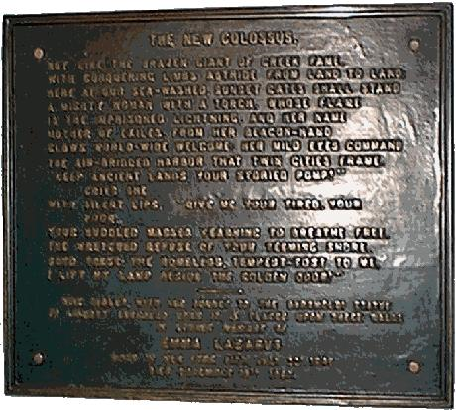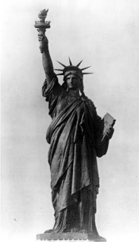

New Colossus Reaction Rubric
Student Name:___________________________
CATEGORY | 4 | 3 | 2 | 1
Organization | Reaction Worksheet has been neatly completed and shows a clear, logical sentence structure (2-3 sentences) for each answer | Reaction Worksheet has been completed but only exhibits a clear, logical sentence structure (2-3 sentences) for two answers. | Reaction Worksheet has been completed but only exhibits a clear, logical sentence structure (2-3 sentences) for one answer. | Reaction Worksheet has not been attempted.
Use of Resources | Information used clearly relates to the immigrant group in question. The answer includes at least two details from today’s stations as evidence for each group. | Information used clearly relates to the immigrant group in question. However, the answer includes only one detail from today’s stations as evidence for each group. | Information used does not relate to the immigrant group in question. Furthermore, the answers do not include details from today’s stations as evidence. | The information used has little or nothing to do with the main topic and is irrelevant.
Graphic Organizer and Connection to Today Worksheet | All boxes and questions are answered with information from today’s stations. | More than half of the boxes and questions are answered with information from today’s stations. | Less than half of the boxes and questions are answered with information from today’s stations. | Answers to the questions are illegible, inappropriate, or not applicable to today’s lesson.
Total: __________________/ 12

A: 11-12
B: 9-10
C: 7-8
D: <7

